[http://sopadeletras.kokolikoko.com/home.gif](http://sopadeletras.kokolikoko.com/)   [http://sopadeletras.kokolikoko.com/more.gif](javascript:show();)

[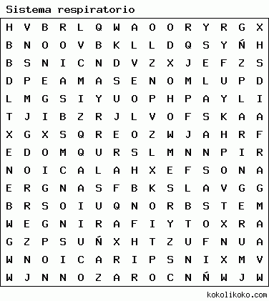](http://sopadeletras.kokolikoko.com/img/180.png?1485112049)

AIRE

ALVEOLOS

BOCA

BRONQUIOS

CORAZON

DIAFRAGMA

EXHALACION

FARINGE

FOSASNASALES

INSPIRACION

LARINGE

OXIGENO

PULMONES

SANGRE